**Web-based Communication with a LabVIEW Application (Real-Time, Windows)**

A web client can exchange data with a remote LabVIEW stand-alone application over a network through LabVIEW Web services. A Web service consists of VIs and other files running on a server that respond to HTTP requests from clients.

A web client, such as a browser, exchanges data with a Web service by sending an HTTP request to a specific URL. LabVIEW maps a URL to each HTTP method VI, so the specific URL that the client uses determines which HTTP method VI receives the HTTP request. The request might contain values to assign to specific parameters in the HTTP method VI. After each request, the HTTP method VI can process those values and return a response. The Web service returns data to the web client in a particular format that you configure, such as XML, **JSON**.

<https://zone.ni.com/reference/en-XX/help/371361R-01/lvconcepts/webservices/>

**Developing HTTP Method VIs (Real-Time, Windows)**

Complete the following steps to create, publish, and exchange data between a LabVIEW Web service and a web client. <https://zone.ni.com/reference/en-XX/help/371361R-01/lvhowto/build_web_service/>

* **Choosing the Format of Output Data**

By default, an HTTP method VI returns data to web clients as an XML string. The XML string includes a summary of the indicator values assigned to the connector pane of the HTTP method VI. You also can configure an HTTP method VI to return data as an HTML-, plain text-, or **JSON**-formatted response.

**Output Type**—Includes the following components for configuring the format that the VI returns data to the Web client:

* **Terminal**—Configures the service VI to output data through the VI terminals.
  + **Output format**—Specifies the output terminal data as XML, text, HTML, or [JSON](javascript:WWW(WWW_JSON)) format.
* **Stream**—Configures the service VI to output data by [streaming the data](https://zone.ni.com/reference/en-XX/help/371361R-01/lvconcepts/ws_configuring_headers/) through the Web Server.
  + **Use headers**—Configures the service VI with streaming output to include [HTTP headers](https://zone.ni.com/reference/en-XX/help/371361R-01/lvconcepts/ws_configuring_headers/).
  + **Buffered**—Configures the service VI to buffer the streaming output.

Create a method VI in LabVIEW Web Service that sends out a response as **JSON** **format**.

Input: http://localhost:8001/TutorialService/Add?a=6&b=5

Output: {"a":6,"b":5,"SUM":11}

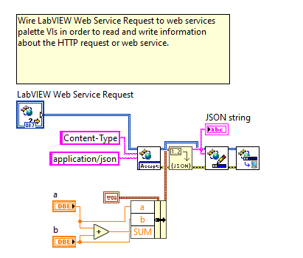

Figure 1: Server Side VI_ **Stream** Output Type_JSON format.

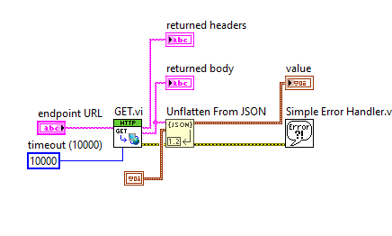

Figure 2: Client Side VI.